**Information System Department**

**Faculty of Computers and Information**

**Cairo, Egypt**

**Data Warehousing**

**Academic Year 2014/2015**

**Phase #1**

**DB source name: Credit DB**

***Done By: Islam Ibrahim***

Source ERD

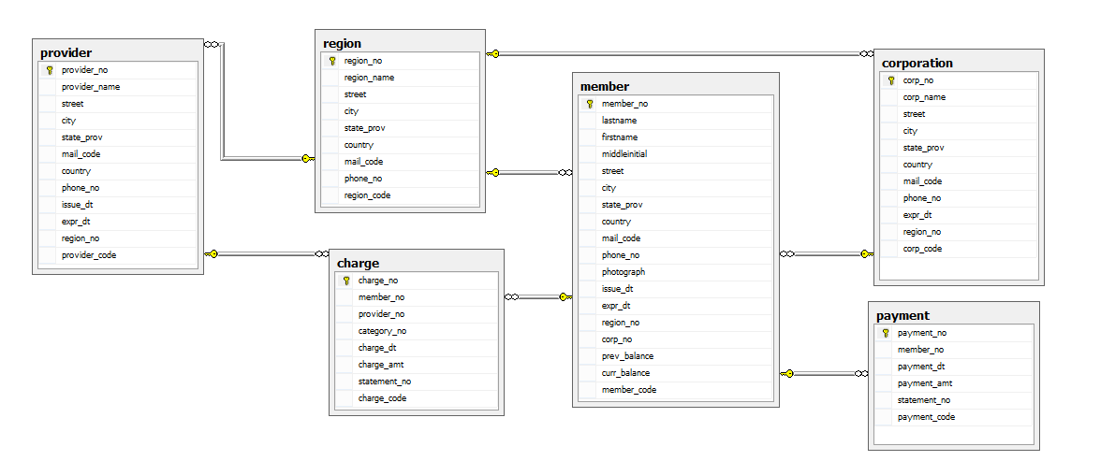

Motivation for creating the star schema

We are creating the Credit charges star schema to analyze statistics about the charges and payments in respect to the members, providers, corporations and in specific intervals of time.

Star Schema Model

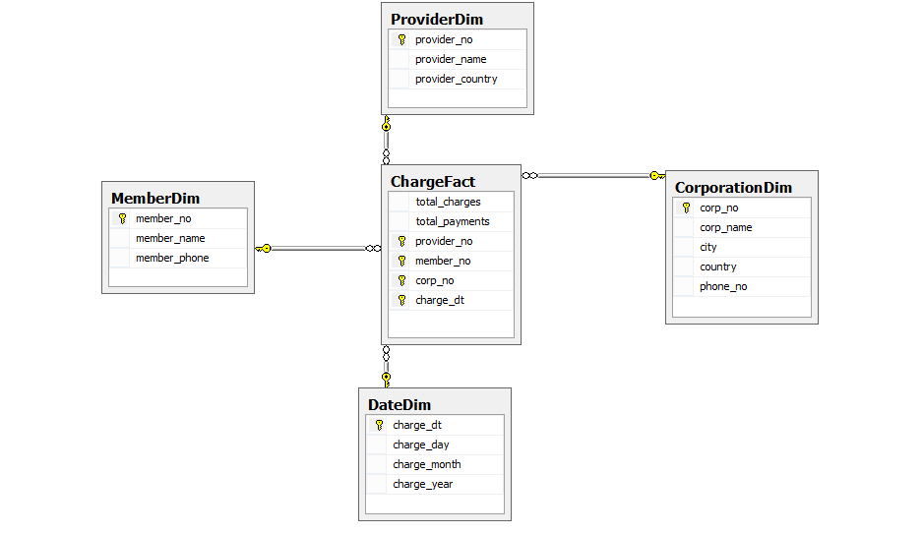

Schema Description

**Dimensions:**

We have 4 dimensions:-

1- MemberDim: this dimension describes the member that have the credit card and who made the charges, the table contains the member number, name and phone number.

Query:

select member.member_no,

member.lastname as member_name, member.phone_no as member_phone

from member

2- ProviderDim: this dimension describes the service provider that provide certain service for a member " meals,cloths … etc", the table contains the provider number, provider name and provider country.

Query:

select provider.provider_no,

provider.provider_name, provider.country as provider_country

from provider

3- CorporationDim: this dimension describes the company that the member belong to, it has two levels ( city, country ), the table contains the corporation number, corporation city, corporation country and corporation name.

Query:

select corporation.corp_no, corporation.city,

corporation.corp_name, corporation.phone_no,

corporation.country

from corporation

4- DateDim: this dimension estimate the date in day, month, year of every charge made by the member, it has three levels

( day, month, year ), the table contains the charge date, and day ,month and year of that charge.

Query:

select charge.charge_dt, DAY(charge.charge_dt) as charge_day,

MONTH(charge.charge_dt) as charge_month,

YEAR(charge.charge_dt) as charge_year

from charge

**Dimensions levels:**

We have two hierarchy's, in DateDim (day, month, year) and in CoroporationDim (city, country).

**Charge Fact:**

In the fact table we will calculate the total charges and the total payments, the table contains the total charges, total payments, member number, provider number, corporation number, charge date.

Query:

select SUM(charge.charge_amt) as total_charges,

SUM(payment.payment_amt) as total_payments,

member.member_no, provider.provider_no,

corporation.corp_no,charge.charge_dt

from charge,payment,member,provider,corporation

where member.corp_no=corporation.corp_no

and payment.member_no=member.member_no

and charge.member_no=member.member_no

and charge.provider_no=provider.provider_no

group by member.member_no, provider.provider_no,

corporation.corp_no,charge.charge_dt

**Measures:**

1- Total charges: it will be all the charges that the members have made them, and its equation will be the sum of the member charges.

2- Total payments: it will be all the payment of a member, and its equation will be the sum of the member payment.